LME545- Forum 1
Sanders

How-To
Microsoft Word: Graphics – Inserting Clip Art; Searching Microsoft’s clip art on the web and downloading; Drawing and Modifying Shapes

This tutorial is designed to help users insert clip art and shapes into word documents.

Inserting Clip Art into Word document from Toolbar:

1. Click Insert
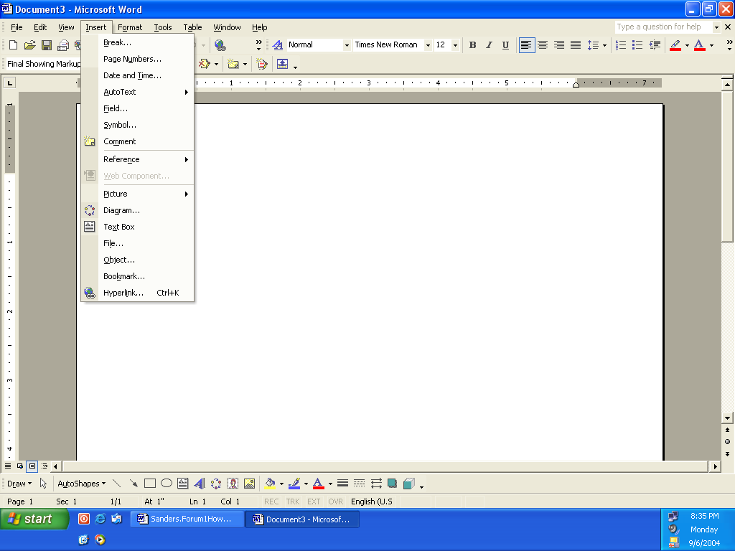

2. Highlight Picture and then highlight Clip Art 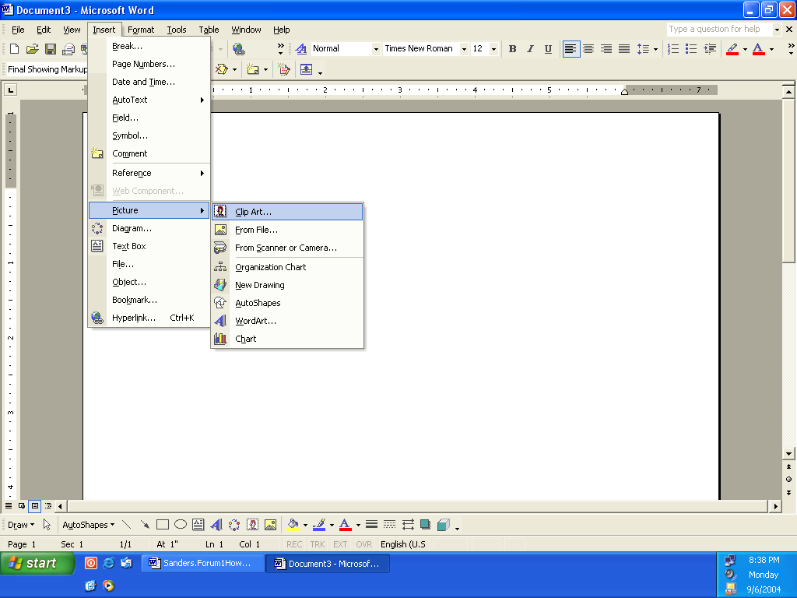

3. Click on Clip Art and then Clip Art toolbar will appear on the right hand side of the screen.
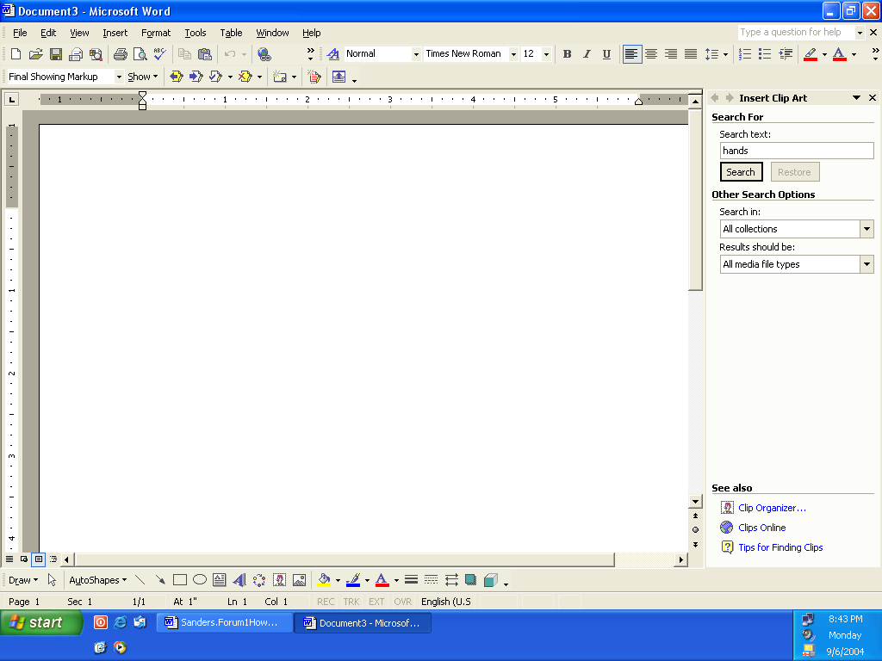

4. Type in the item you want to insert into your document and then click on search.
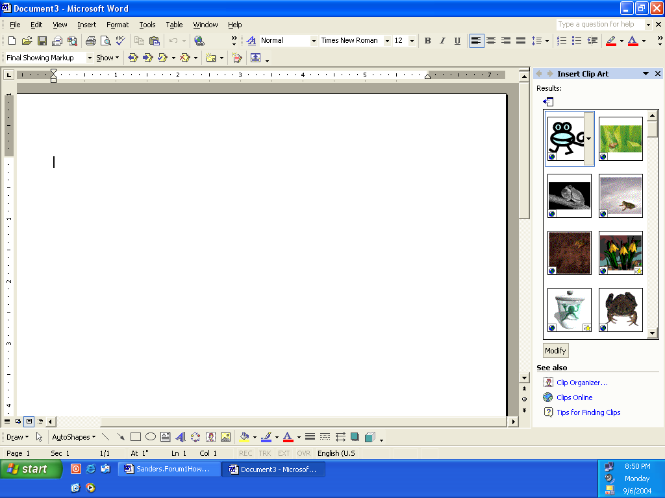

5. Once you find the object or picture you would like to add to your document you will need to click on the object. It will then be added into your document.

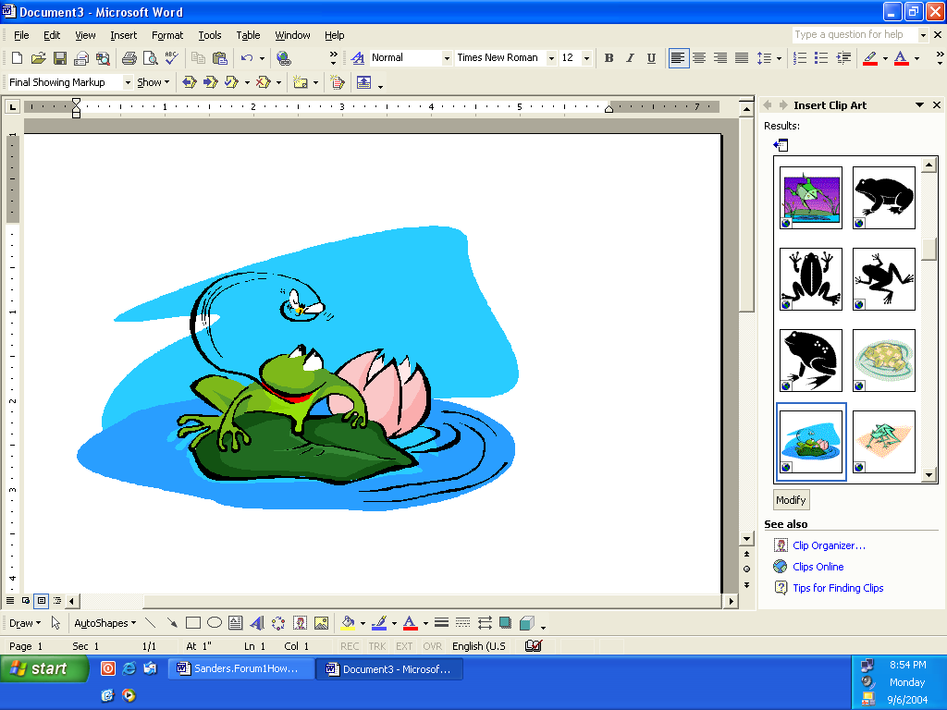

Modifying the size or shape of your clip art:

1. If your image needs to be larger or smaller you will need to click on the image and an outline will appear around the entire image.
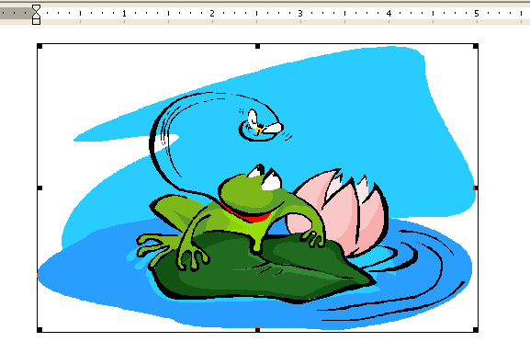

2. Depending on what size you need the image to be put your cursor one of the black dots. Your cursor will change to a line with arrows on both ends. Once your cursor is on the dots you can pull in and out with the cursor, resizing your image to the size that you need it to be.

Clip Art on the Web and Downloading:

1. If you can not find an image that you like you may search for clips online. You will find this option at the bottom of the clip art search menu.
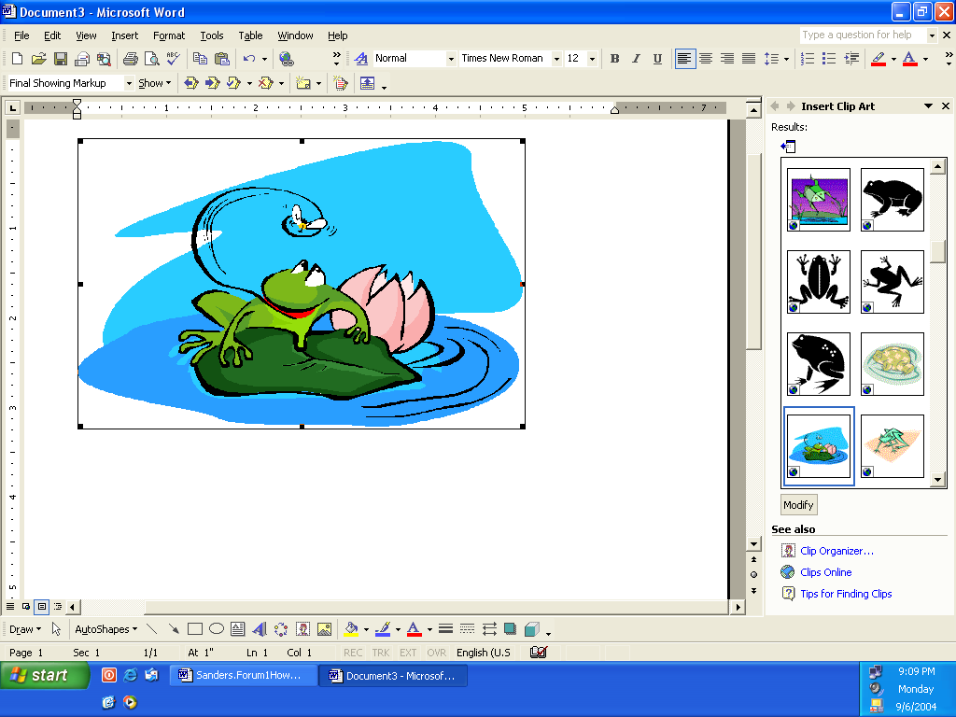

2. Click on Clips Online and you will be taken to Microsoft Office Online.

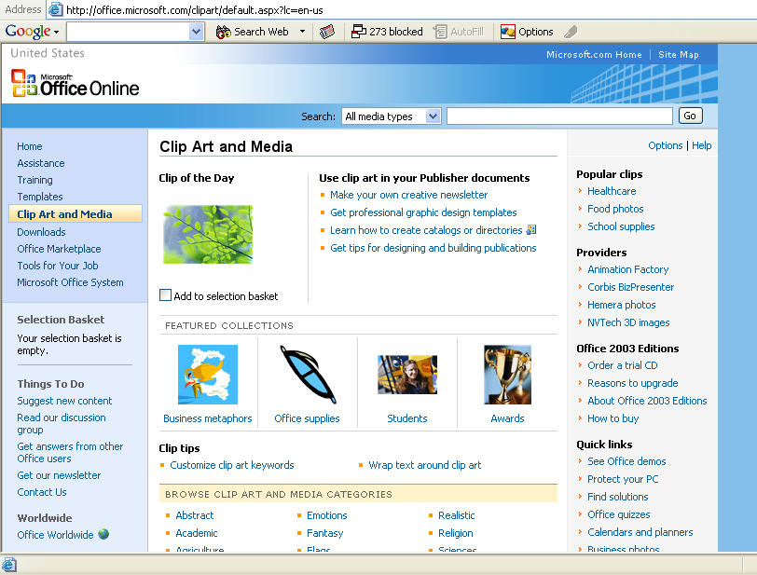

3 Once on this site you can search thru many different types of media to find the clip art image that you are looking for.

4. Once you find the item you need click to box under it and a check will appear. This means that you have added the image into the selection basket. This will appear on the left hand side of the screen.
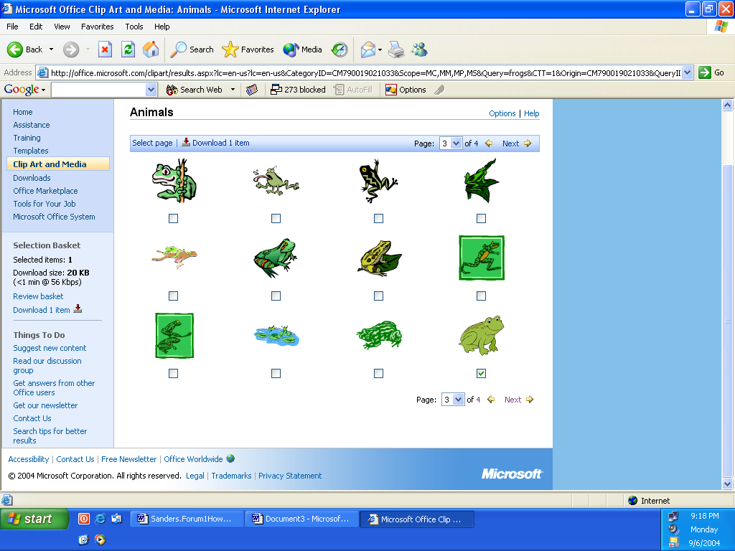

5. Now will need to download the image into your documents.
Click download 1 item from the selection basket.
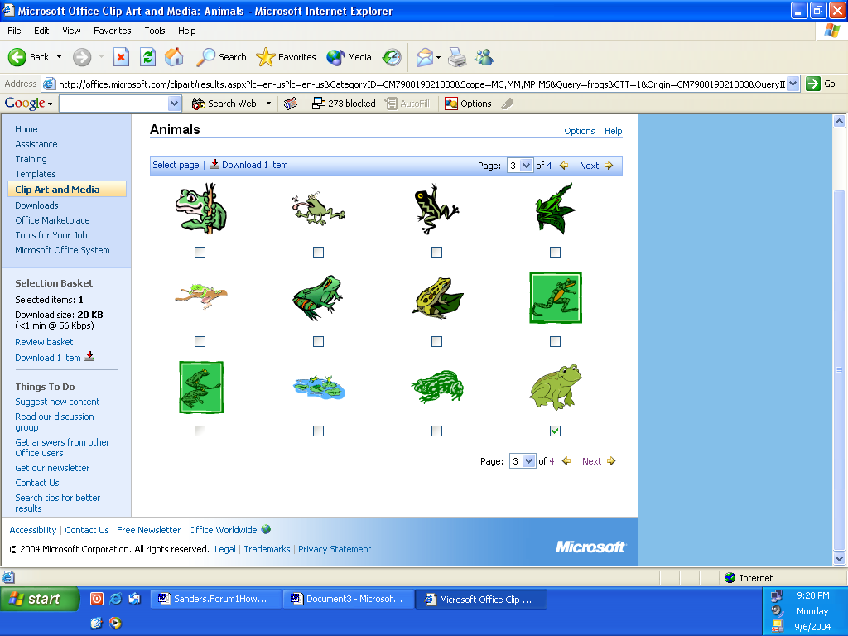

6. You will need to read and accept the End User License Agreement.

7. Once you have accepted the agreement you are ready to download. All you need to do now is click on Download Now.
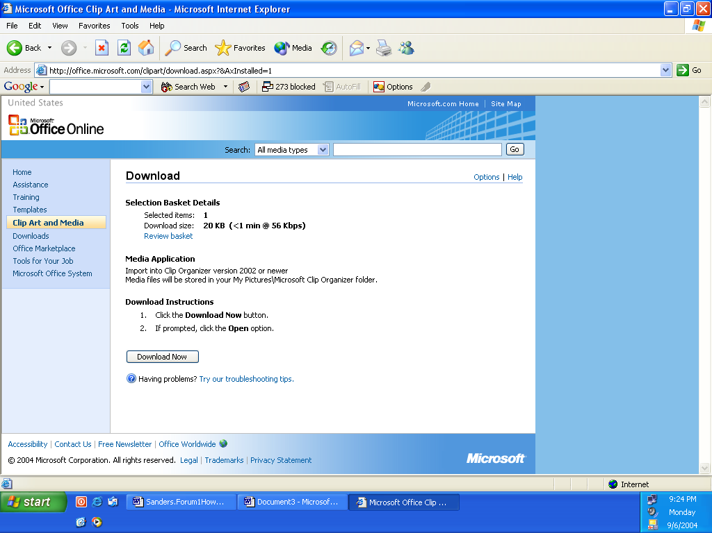

8. Your image will now be added into your Microsoft Clip Organizer.
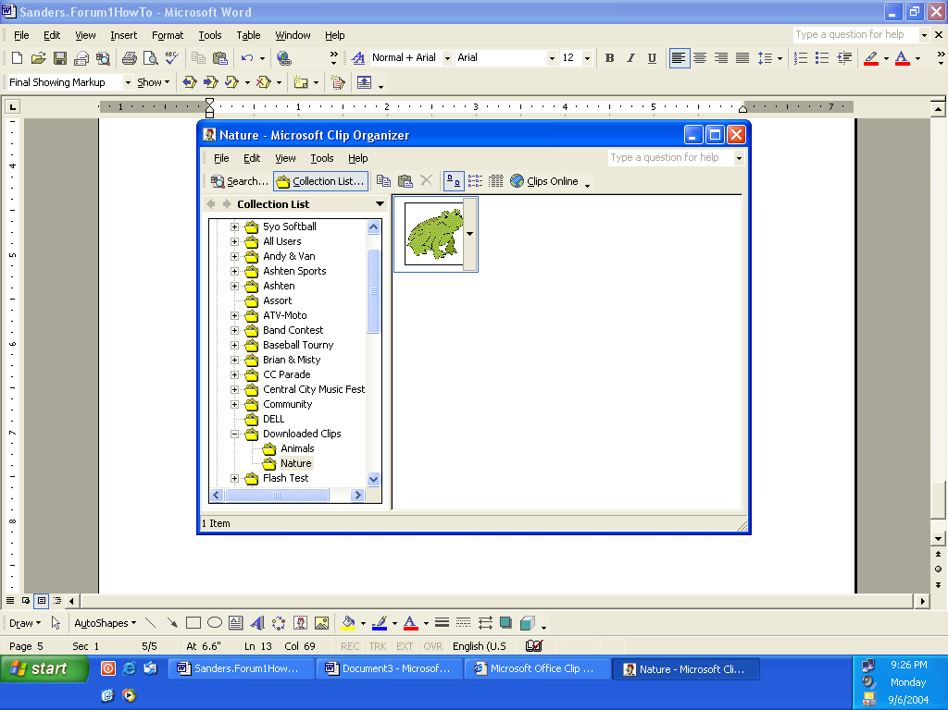

9. Your image is now in the clip organizer and you will be able to add it into your document and resize if needed.

Drawing and Inserting Shapes:

1. To insert shapes into a document click on insert and highlight picture, then click on AutoShapes.
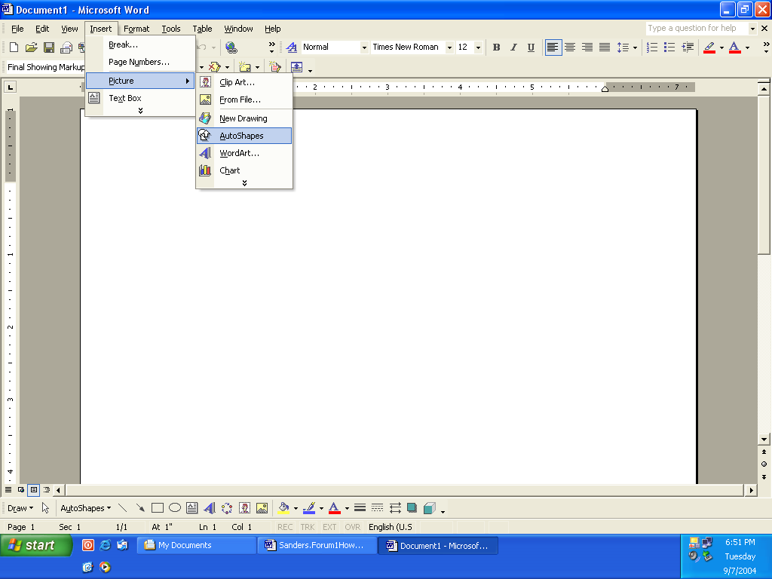

2. Click AutoShapes and then a toolbar will appear.
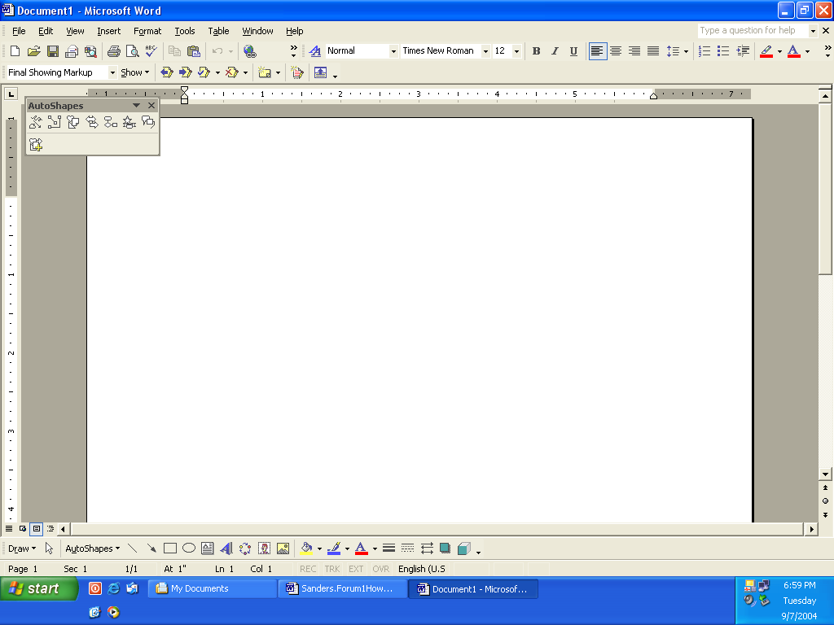

3. Click on desire set of shapes that you would like to choose from.
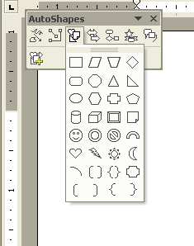

4. Double click on shape that you would like to add into your document. A box will appear and you will need to click somewhere in the box.
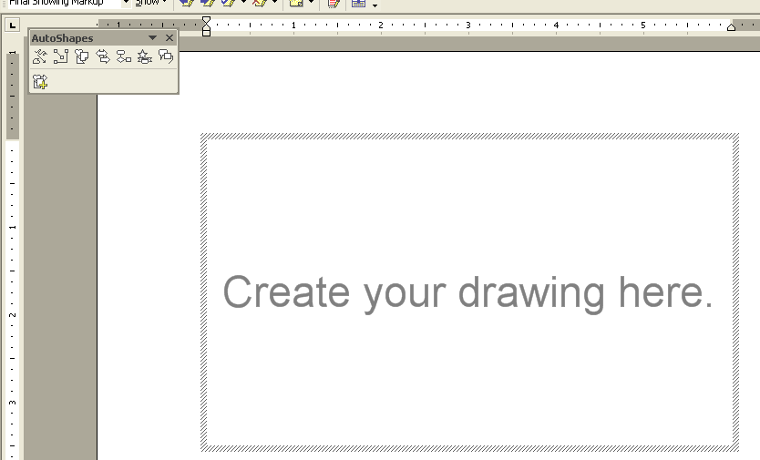

5. Once you click in the box the shape will appear. If you need to make the shape bigger or smaller click on one of the black dots and draw in the mouse to make the shape the desired size.
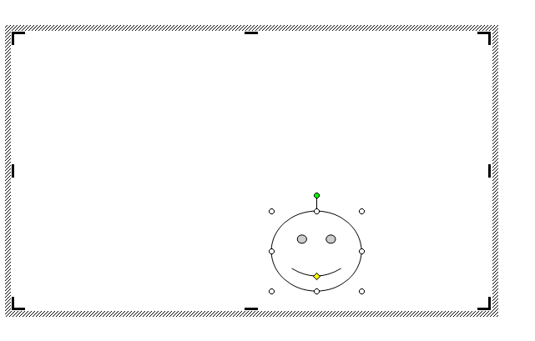
6. By putting your cursor in the middle of the shape, you will be able to move the shape to its needed position in your document.

References
Microsoft Office Clipboard, Retrieved on September 6, 2004
http://office.microsoft.com/clipart/default.aspx?lc=en-us

