Deborah K. Conner
LME 545
Forum 1: How To….
Fall 2004

Working With Charts

Although information may be organized effectively using spreadsheets, charts provide a way to communicate relationships with data in a quick fashion. Following we will create a chart and step through the ease of designing this informational format.

First, we will enter information into a spreadsheet:

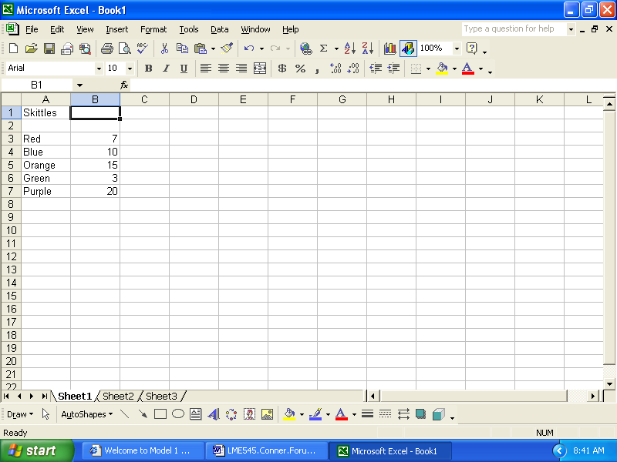

Now to begin charting:

- Click the Chart Wizard button or select Chart from the Insert menu

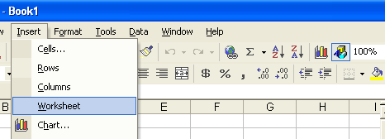

2. Choose the Chart Type (here you have several options, the most used is the bar chart)
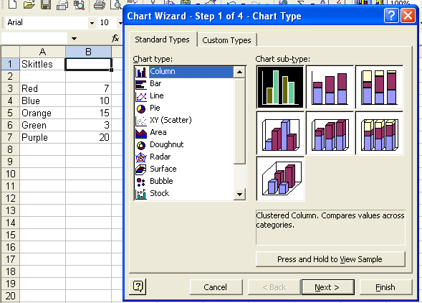

- Click the Next button

- Make any needed changes to Data Range and Series (usually no change); then click Next button.
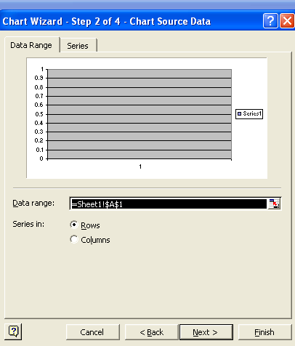

- Click the appropriate tab to make changes to the Titles, Axes, Gridlines, Legend, Data, Labels, and data table; then click the Next button
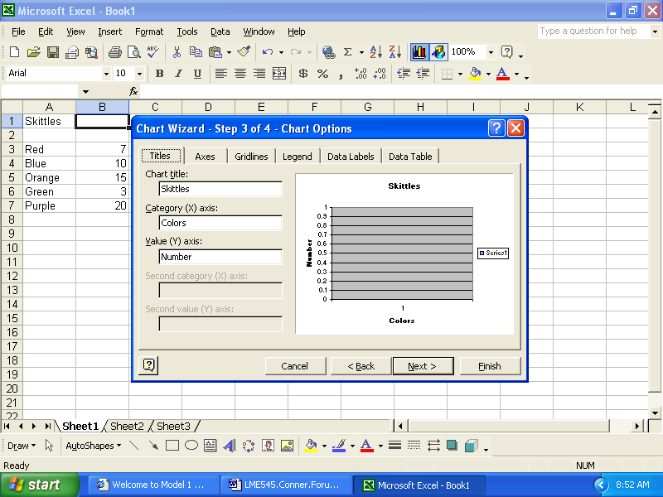

Other options that are often used from this screen is the Legend which shows a miniature chart that color codes the bars in the chart and Data labels provide the values over the individual bars to identify the number.

- Choose the chart location. You can specify whether to create a new chart sheet or place the chart on an existing worksheet then click the Finish button.
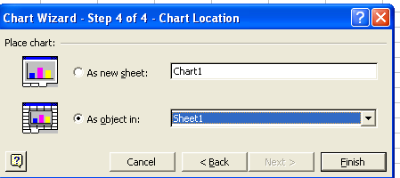

- Move the chart by dragging it to the desired location on the worksheet
- Use the handles around the chart for resizing.

References

Creating Great Looking Charts in Excel. (n.d.) Retrieved Monday, September 06, 2004 from http://www.microsoft.com/mac/products/excel2004/using.aspx?pid=usingexcel2004&type=howto&article=/mac/LIBRARY/how_to_articles/office2004/xl_GreatCharts.xml

Halvorson, Michael. (1995). Microsoft Office Professional. Boston. ITP Company.

Quick Tips for Excel.(n.d.) Retrieved Monday, September 06, 2004, from http://www.kenton.k12.ky.us/quicktips/Excel.html.

