Chapter 7
Reporting and Interpreting Inventories and Cost of Goods Sold
Inventory Management Decisions:
The primary goals of inventory managers are to:
1. Maintain a sufficient quantity to meet customers’ needs
2. Ensure quality meets customers’ expectations and company standards
3. Minimize the costs of acquiring and carrying the inventory
Types of Inventory
Merchandisers
- Buy finished goods
- Sell finished goods
Manufacturers
- Buy raw materials
- Produce and sell finished goods

Merchandise
Inventory
Raw Materials
Work in Process
Finished Goods
Waiting to be processed
Partially complete
Awaiting sale

Balance Sheet and Income Statement Reporting
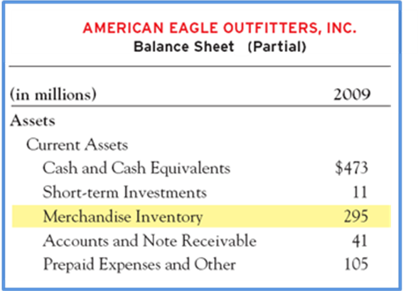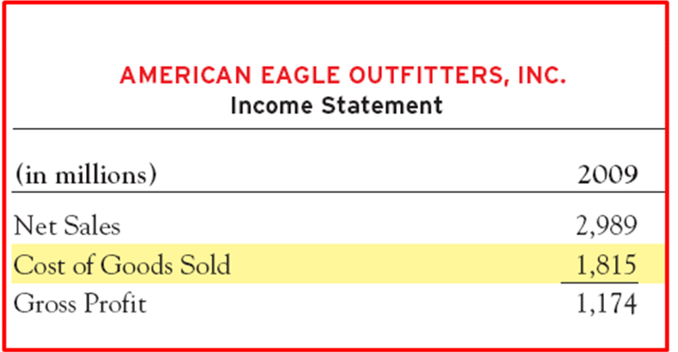

Cost of Goods Sold Equation: BI + P – CGS = EI
American Eagle Outfitters’ beginning inventory was $4,800. During the period, the company purchased inventory for $10,200. The cost of goods sold for the period is $9,000. Compute the ending inventory.
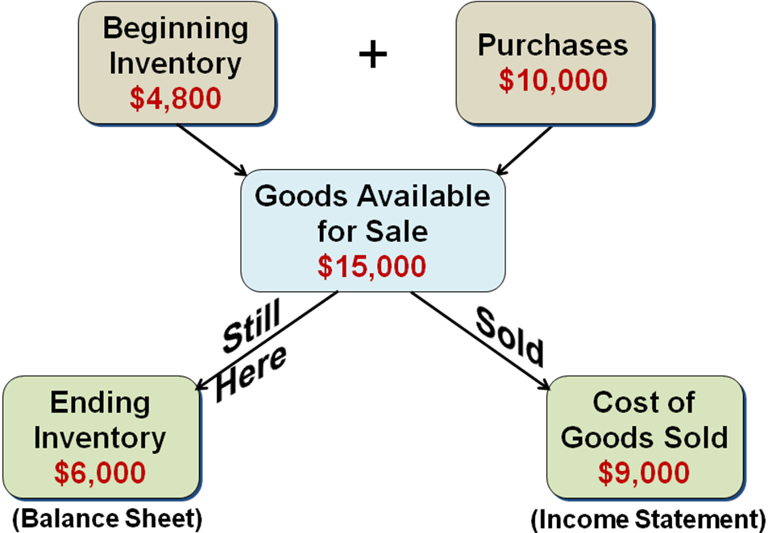
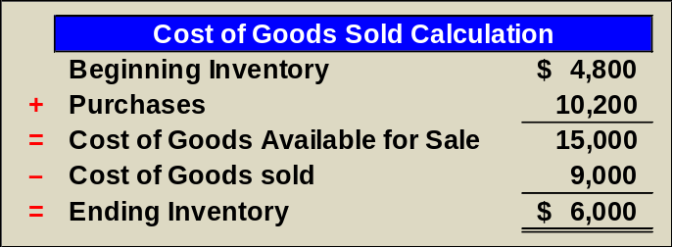

Inventory Costing Methods
- Specific Identification
- First-in, first-out
- Last-in, first-out
- Weighted average
Consider the following information:
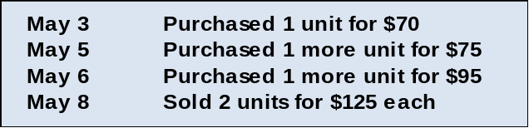

Specific Identification: This method individually identifies and records the cost of each item sold as part of cost of goods sold. If the items sold were identified as the ones that cost $70 and $95, the total cost of those items ($70 + 95 = $165) would be reported as Cost of Goods Sold. The cost of the remaining item ($75) would be reported as Inventory on the balance sheet at the end of the period.
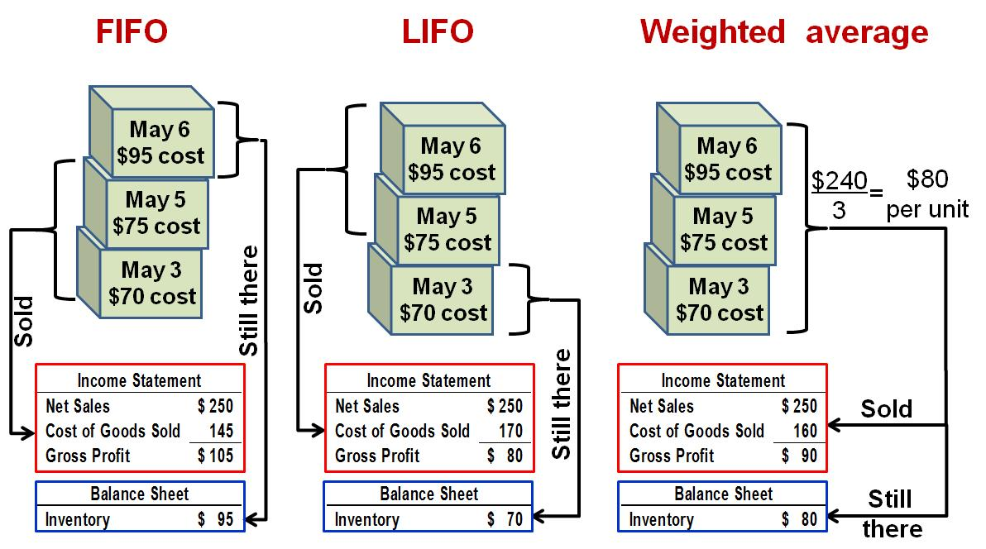
Summary
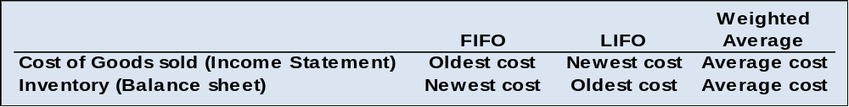

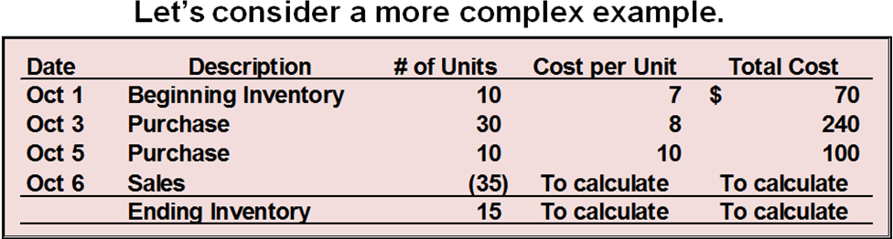

Inventory Cost Flow Computations
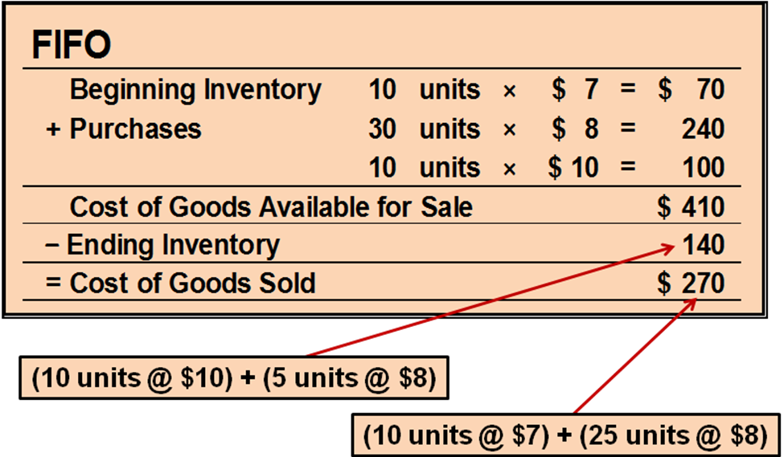

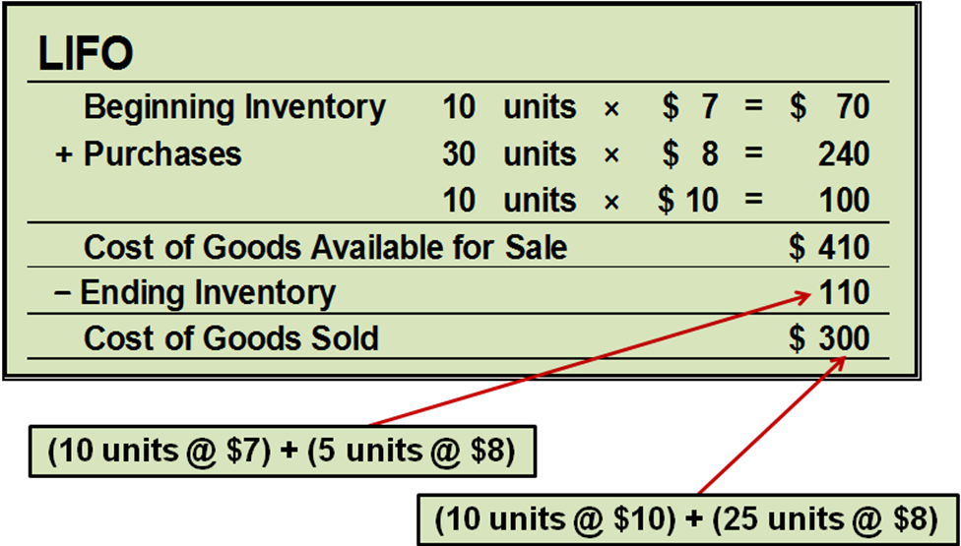

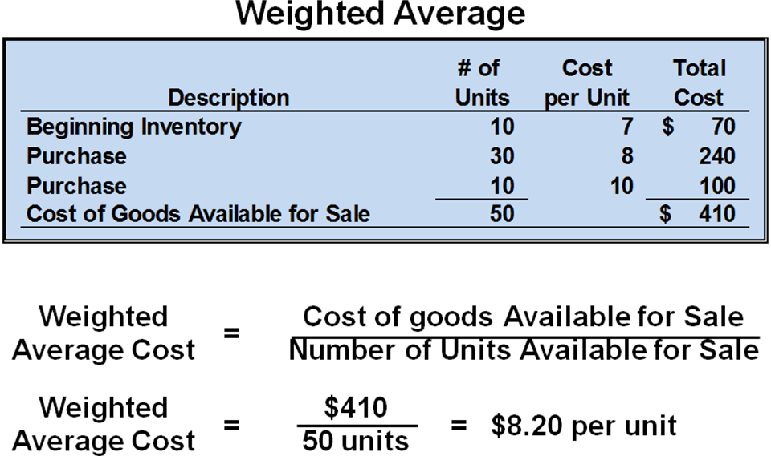

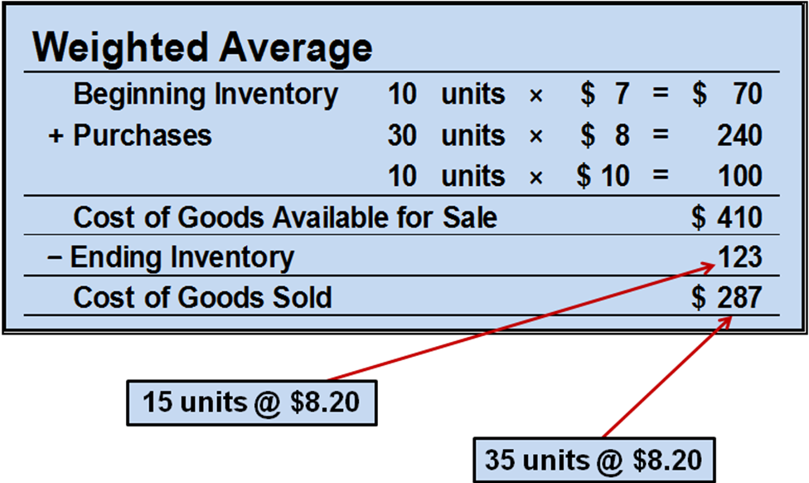
Financial Statement Effects
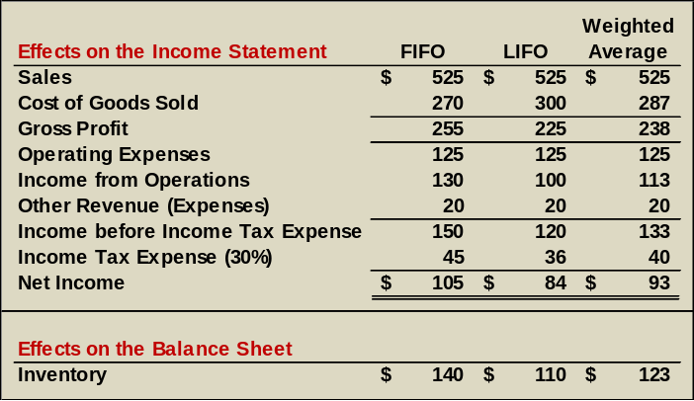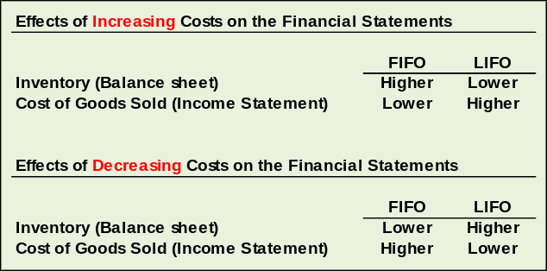

Advantages of Methods
Weighted Average - Smoothes out price changes.
First-In, First-Out - Ending inventory approximates current replacement cost.
Last-In, First-Out - Better matches current costs in cost of goods sold with revenues.
Tax Implications and Cash Flow Effects
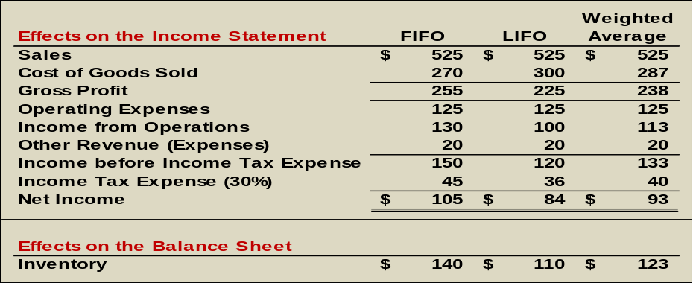

Lower of Cost or Market
The value of inventory can fall below its recorded cost for two reasons:
- it’s easily replaced by identical goods at a lower cost, or
- it’s become outdated or damaged.
When the value of inventory falls below its recorded cost, the amount recorded for inventory is written down to its lower market value. This is known as the lower of cost or market (LCM) rule.
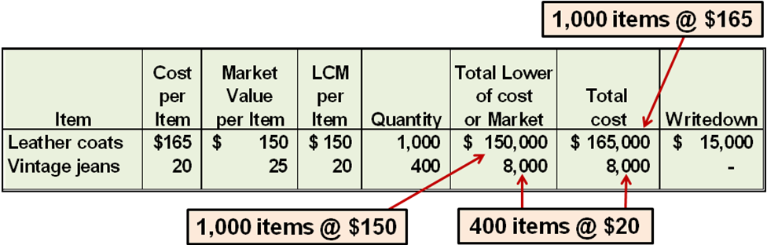
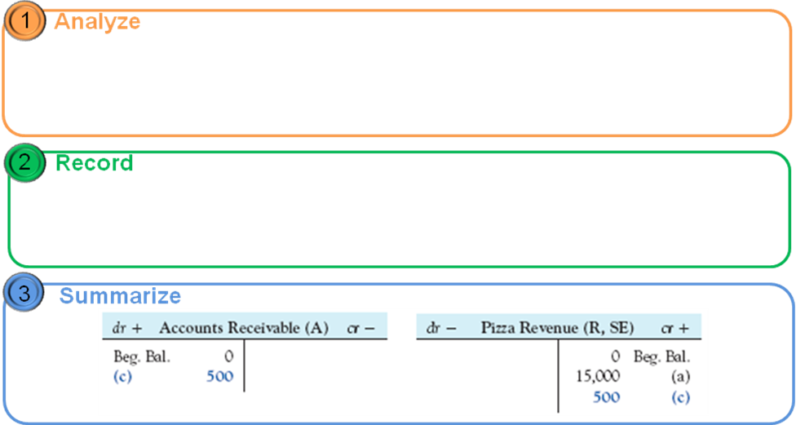

Inventory Purchases
American Eagle Outfitters purchases $10,500 of vintage jeans on credit.
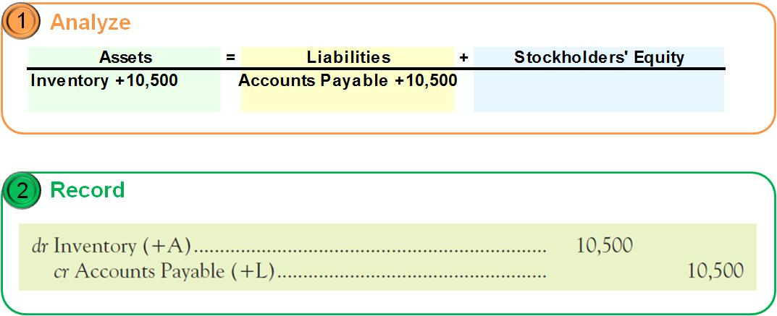

Transportation Cost
American Eagle pays $400 cash to a trucker who delivers the $10,500 of vintage jeans to one of its stores.
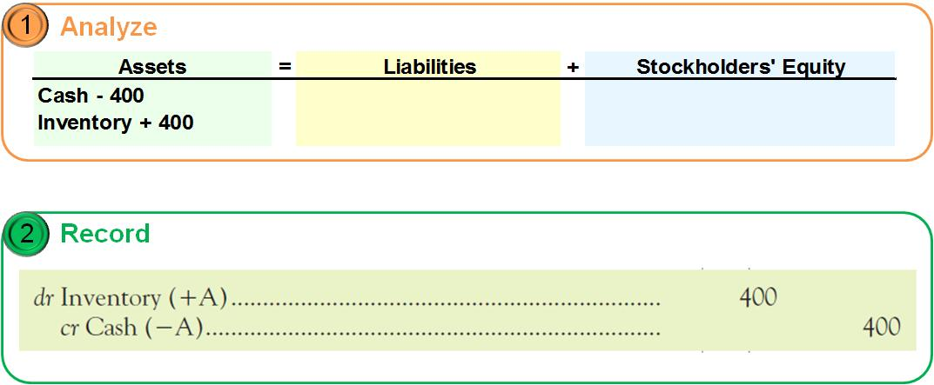

Purchase Returns and Allowances
American Eagle returned some of the vintage jeans to the supplier and received a $500 reduction in the balance owed.
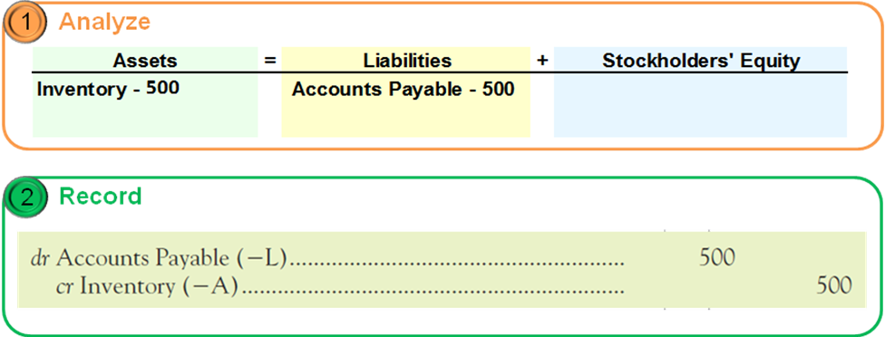

Purchase Discounts
American Eagle’s vintage jeans purchase for $10,500 had terms of 2/10, n/30. Recall that American Eagle returned inventory costing $500 and received a $500 reduction in its Accounts Payable. American Eagle paid within the discount period.
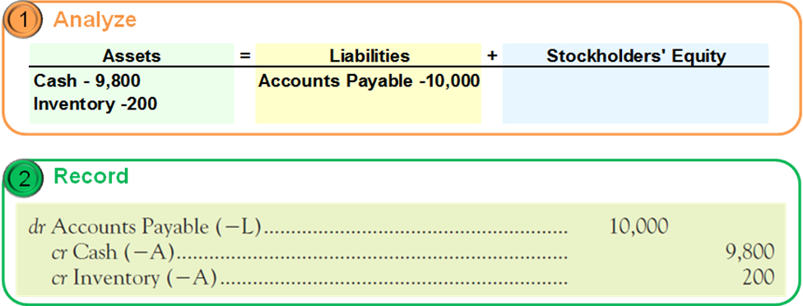

Summary of Inventory Transactions
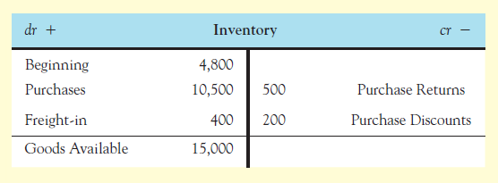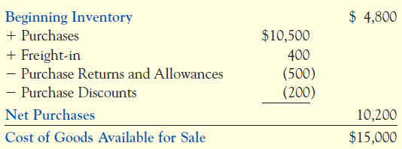

Inventory Turnover Analysis
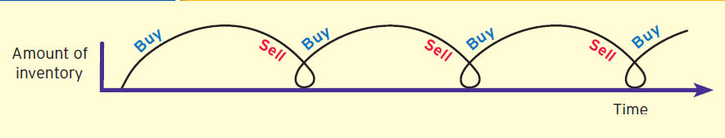
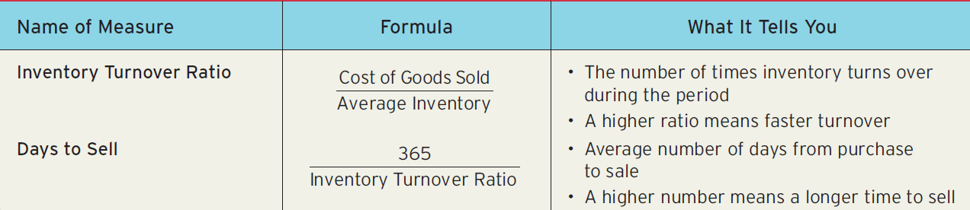

Comparison to Benchmarks
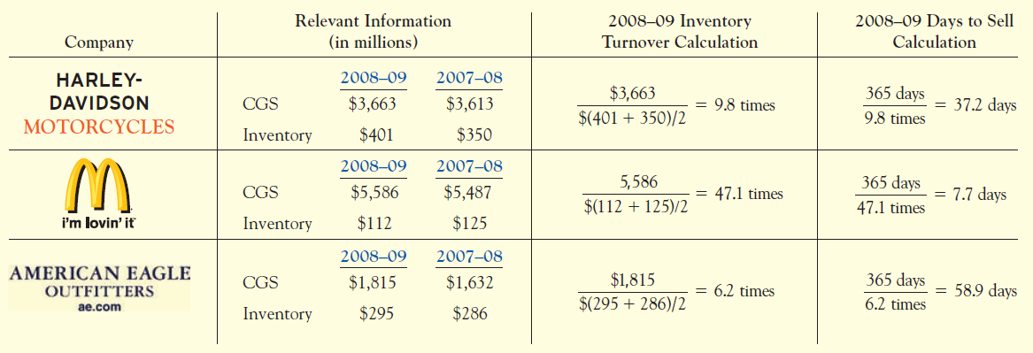

Perpetual Inventory System
This is the same information that we used earlier in the chapter to illustrate a periodic inventory system. The only difference is that we have assumed the sales occurred on October 4, prior to the final inventory purchase.
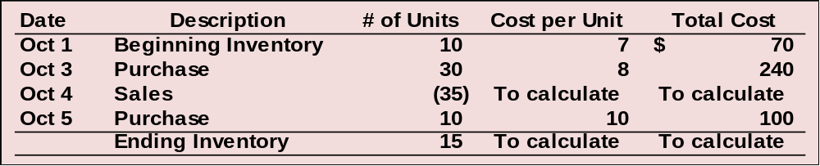

FIFO (First-in, First-Out)
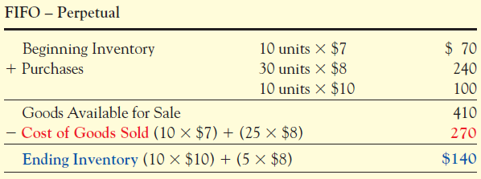
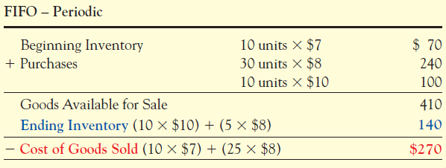
LIFO (Last-in, First-Out)
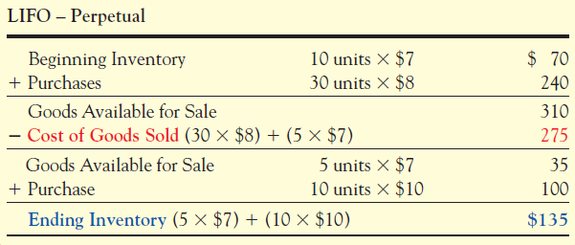
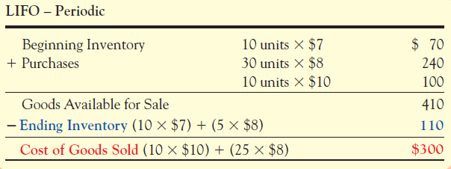

Weighted Average Cost
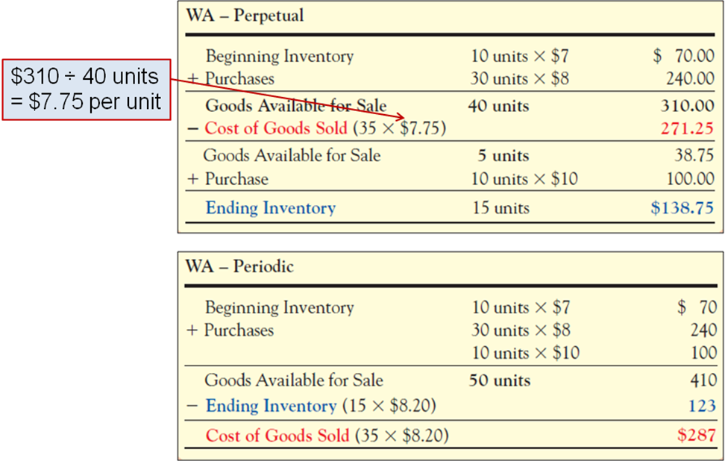

Financial Statement Effects
Summary of Perpetual Inventory System Cost Flow Assumptions on Financial Statements
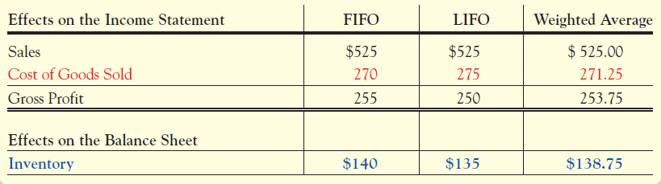

The Effects of Errors in Ending Inventory
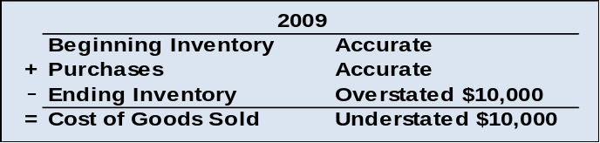 Assume that Ending Inventory was overstated in 2009 by $10,000 due to an error that was not discovered until 2010.

Now let’s examine the effects of the 2009 Ending Inventory Error on 2010.
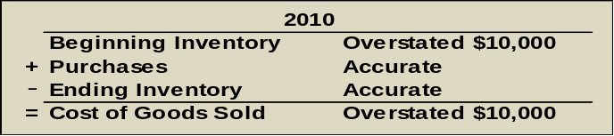

Recording Inventory Transactions in a Periodic System
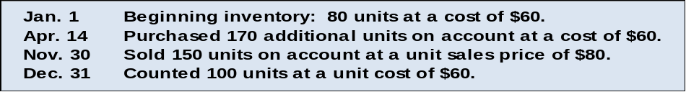A local cell phone dealer stocks and sells one item, the MOTORAZR phone. The following events occurred in the past year:

We will record these events assuming the company uses a periodic inventory system and then compare the periodic inventory system to a perpetual inventory system.
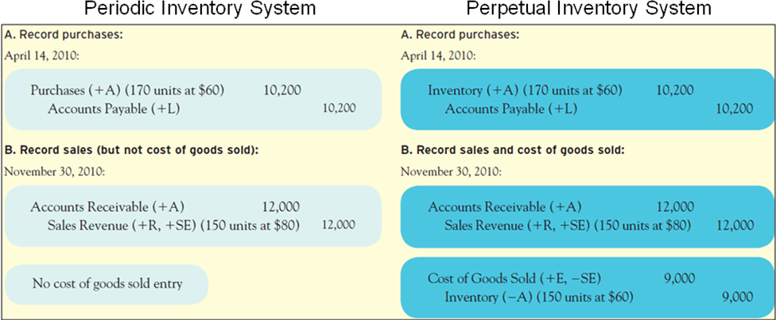
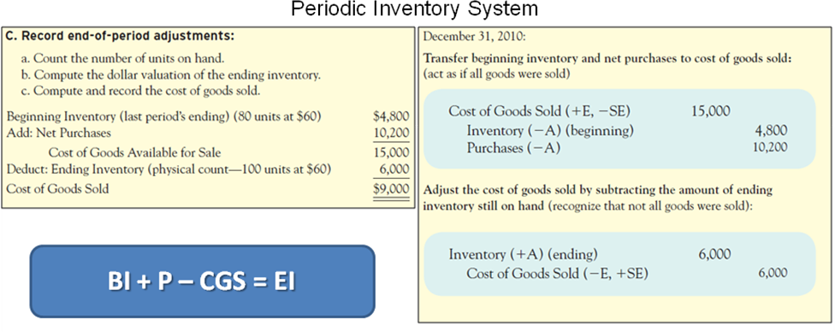
End-of-year adjustment entries are not required using a perpetual inventory system.
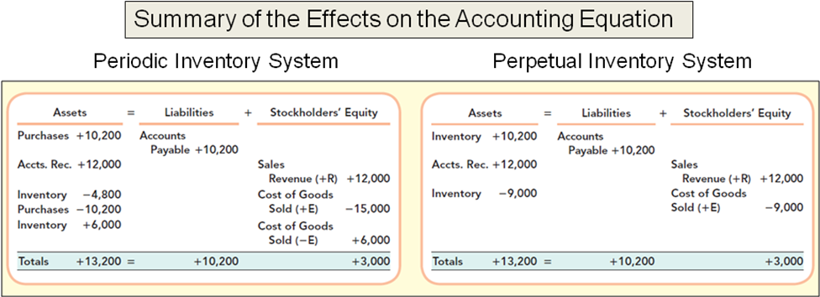
Exercises
M7-6 Calculating Cost of Goods Available for Sale, Ending Inventory, Sales, Cost of Goods Sold, and Gross Profit under Periodic FIFO, LIFO, and Weighted Average Cost
Given the following information, calculate cost of goods available for sale and ending inventory, then sales, cost of goods sold, and gross profit, under (a) FIFO, (b) LIFO, and (c) weighted average. Assume a periodic inventory system is used.
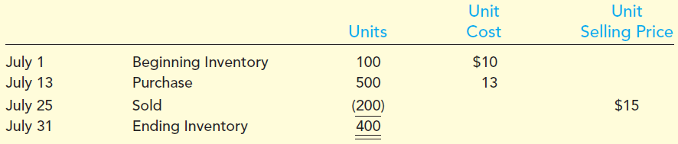

M7-7 Calculating Cost of Goods Available for Sale, Cost of Goods Sold and Ending Inventory under FIFO, LIFO, and Weighted Average Cost (Periodic Inventory)
Given the following information, calculate the cost of goods available for sale, ending inventory, and cost of goods sold, assuming a periodic inventory system is used in combination with (a) FIFO, (b) LIFO, and (c) Weighted Average Cost.
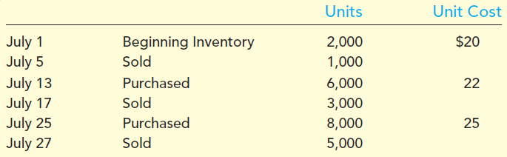

E7-3 Inferring Missing Amounts Based on Income Statement Relationships
Supply the missing dollar amounts for the 2010 income statement of Lewis Retailers for each of the following independent cases.
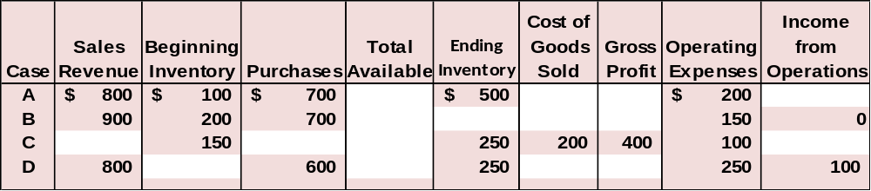

E7-5 Calculating Cost of Ending Inventory and Cost of Goods Sold under Periodic FIFO, LIFO, and Weighted Average
Assume Oahu Kiki’s uses a periodic inventory system, which shows the following for the month of January. Sales totaled 240 units.
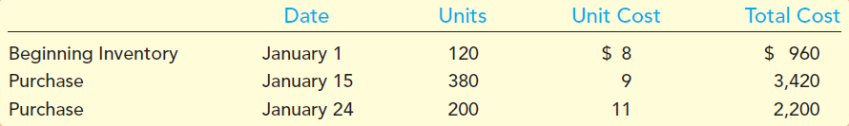

Required:
- Calculate the number and cost of goods available for sale.
- Calculate the number of units in ending inventory.
- Calculate the cost of ending inventory and cost of goods sold using the
(a) FIFO, (b) LIFO, and (c) weighted average cost methods.
E7-10 Reporting Inventory at Lower of Cost or Market
Peterson Furniture Designs is preparing the annual financial statements dated December 31, 2009. Ending inventory information about the five major items stocked for regular sale follows:
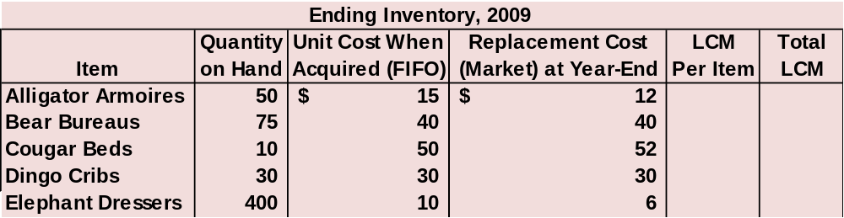

Required:
1. Complete the final two columns of the table and then compute the amount that should be reported for the 2009 ending inventory using the LCM rule applied to each item
2. Prepare the journal entry that Peterson Furniture Designs would record on December 31, 2009.
3. If the market values recovered by June 30, 2010, to greater than original cost, would the journal entry in requirement 2 be reversed under GAAP? Under IFRS?
E7-17 Analyzing and Interpreting the Inventory Turnover Ratio
Polaris Industries Inc. is the biggest snowmobile manufacturer in the world. It reported the following amounts in its financial statements (in millions):
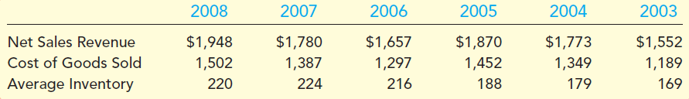
Required:
1. Calculate to one decimal place the inventory turnover ratio and average
days to sell inventory for 2008, 2007, and 2006.
2. Comment on any trends, and compare the effectiveness of inventory
managers at Polaris to inventory managers at its main competitor, Arctic
Cat, where inventory turns over 4.5 times per year (81.1 days to sell).
Both companies use the same inventory costing method (FIFO).

