Making the Next Bailout the Last

Ben Bernanke is worried about whether the Fed has the political capital to do it all again.
- By HOLMAN W. JENKINS, JR.
- Like this columnist
The European debt crisis isn't over, and may indeed get a lot worse if the new strategy (as appeared on Friday) is to let European banks borrow unlimited funds from the European Central Bank to cycle back into the bonds of spendthrift governments. If the stock market seems happy, it's only because the meltdown has been postponed.
Since another bailout of the U.S. financial system may yet be needed as a result of the European mess, it behooves us to ask what we learned from the last one. Happily there was plenty of news this week to help us.
Financial pros were buzzing about a Bloomberg News story that had then-Treasury secretary Henry Paulson, on July 21, 2008, stopping by a hedge fund and musing about wiping out Fannie Mae and Freddie Mac's shareholders and placing the mortgage lenders under government conservatorship, as he did seven weeks later.
On most lips was the question: Did Mr. Paulson tip his hand in a way that let shortsellers make a fortune betting against Fannie and Freddie? Our concern is different. The Bloomberg revelations should also be profoundly irritating to anyone who heard and believed Mr. Paulson's public pronouncements at the time, suggesting Fannie and Freddie were properly capitalized and indicating that their shareholders would be protected.
We're thinking of people like fund managers Bill Miller and Eddie Lampert, who were holders of Fannie and Freddie stock, as they later made known, partly on Mr. Paulson's say-so.
Their subsequent grief was featured in a column here, in which they argued that this double cross led directly to the collapse of equity values across the financial system. Erased along the way was the Bush administration's frantic hope at the time of recruiting private investors to recapitalize the banking system so taxpayers wouldn't have to.
Enlarge Image
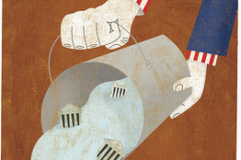
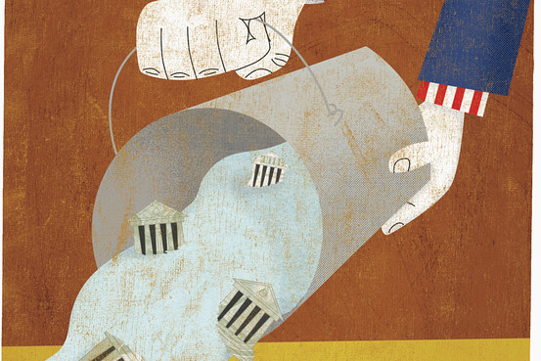
Getty Images
This might be water under the bridge if the cycle of self-defeat hadn't continued under the new administration. Early on, in order to declare the crisis solved, Team Obama produced "stress tests" purporting to show that the banks' future earnings would be sufficient to cover their future long-term losses. Investors took this as a sign to buy bank shares. Then Washington proceeded to bombard the banks with regulatory actions, lawsuits and vilifying rhetoric that destroyed all over again the market confidence so expensively bought.
Today, the biggest banks are even bigger. Yet look at their miserable stock prices. One consequence is that there's no chance—zero—of private capital stepping in to help the banks handle losses from a European meltdown.
Which brings us to the second relevant news item of the week. Washington, and the Federal Reserve especially, intervened heavily after the Lehman collapse to quell an immediate liquidity panic. Whatever the utility of that bailout, it didn't solve any long-term problem, leaving us a handful of supergiant banks limping along the edge of a confidence meltdown. It also left us with a public deeply distrustful of financial regulators.
In an unusual and lengthy letter to Congress this week, Fed Chief Ben Bernanke complained about certain unnamed press outlets and labored to rebut the idea that Fed actions in 2008-2009 had merely stuffed taxpayer money into the pockets of undeserving bankers. Did the Fed save us from another Great Depression? We'll never know. But Mr. Bernanke is clearly worried that his and Washington's political capital may not be up to doing it a second time.
Here's where the loop gets closed. All the more important, then, for future policy, and for getting us off the bubble-and-bust cycle, is the following question: Were the banks smoking in bed or were they victims of a fire started elsewhere? Everybody knows the answer. Yet shockingly little progress has been made in reducing the incentive of the banking system to smoke in bed.
There are answers wherever you look. Reform the deposit insurance system. Require banks to take on a class of creditor who would be legally obligated to ante up if a bank needs recapitalization because of excessive losses. Correct a regulatory strategy that works by incentivizing banks to treat certain assets—mortgages, Greek debt, Italian debt—as risk-free. This, inevitably, leads to the overproduction of these assets until the system blows up.
Unfortunately, government, having empowered itself in the crisis, is doing what government does. It is taking more, not less, control in telling banks what assets to invest in. Dodd-Frank didn't so much cure too-big-to-fail as institutionalize it. The Corzine fiasco is being turned into yet another miseducational moment in which investors are encouraged to believe that it's the job of government to protect them from losses.
Down this road lies financial crises without end, assuming we survive the current one

